Admiral Augustus L. Case and The Case Villa
16 Catherine Street
For this newsletter I chose a house near and dear to me. My very own home built by Rear Admiral Augustus Ludlow Case and his wife Anna Rogers. The house hits a milestone this March turning 150 years old.
Augustus L. Case was born in Newburgh, NY to a family with a prominent naval pedigree. In fact, he was named in honor of his uncle Lieutenant Augustus Ludlow who was killed during the War of 1812 in the naval battle between the USS Chesapeake and HMS Shannon. Ludlow, second in command, received the famous order “don’t give up the ship” from the mortally wounded Captain Lawrence before succumbing to his own wounds. Case’s mother decided to name her newborn son after her deceased brother in 1813.
Case joined the Navy at a very young age, he attained the rank of Midshipmen by 1828 at the age of 15. He would face hardship and danger throughout his illustrious naval career which started as a member of the Wilkes Expedition (United States Exploring Expedition) from 1838-1842. The expedition was of major scientific importance to the young United States, many of the plant and animal species collected were acquired by the Smithsonian. The expedition also discovered a large portion of Antarctica known today as Wilkes Land. By expeditions end, they had circumnavigated the globe. Sea of Glory by Nathaniel Philbrick is a great account of the expedition, Case is even mentioned in the book.
Lieutenant Case also fought in the Mexican American war from 1846-1848 supervising the landing of men, ordnance, and stores for the siege of Vera Cruz. When the Civil War broke out he was appointed Fleet-Captain of the North Atlantic Blockade Squadron where he took part in the capture of Fort Clarke and Hatteras in North Carolina. By 1872 he had earned the rank of Rear Admiral and retired shortly after.
Admiral Case and his wife Anna Rogers built their Newport home on Catherine Street, the former site of the Bellevue Hotel, and took possession of it in March 1873. Anna had a deep connection to Newport, she could trace her family roots back to the founding of the city. The Admiral and his wife lived in the home with their three children, Annie, Gus Jr., and Daniel. Both boys attended the Naval Academy in Annapolis. The family welcomed friends to the home such as John Singer Sargent on his first trip to the United States in the summer of 1876. One of Sargent’s early landscape paintings “Oyster Gathers at Cancale” was purchased by the family, donated years later, it now hangs on the second floor of the Smithsonian. Sargent also sketched and painted members of the Case family. The Admiral would also receive old military acquaintances such as William Tecumseh Sherman who visited the home in 1877 after his inspection of Fort Adams and the Goat Island Torpedo Station.
Unfortunately, tragedy would also be part of the Case family story. The Admiral, who had faced death numerous times in the Navy would face it throughout his personal life. In 1851 the parents lost their four-year-old daughter Maria. In 1876, just after her marriage to Charles Deering, Anna died shortly after childbirth at age 28. She was buried on her one-year wedding anniversary. By 1890 Gus Jr. had drown off of Poppasquash Point in Bristol trying to reach an unmoored skiff during a storm, Daniel barely survived the incident. Anna Rogers would die shortly after the tragedy in 1891. The Admiral spent his last years living in Washington D.C. a few blocks from the Whitehouse. He would die in 1893. The family are all buried together in Island Cemetery. Every house has a story…

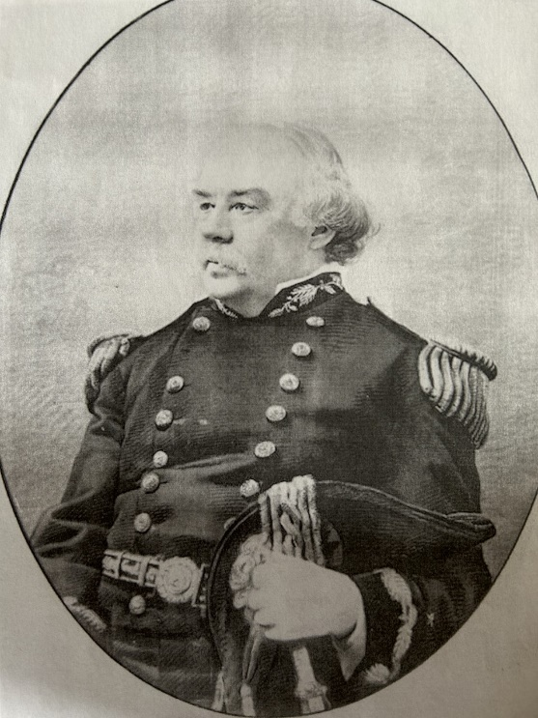
Rear Admiral Augustus L. Case

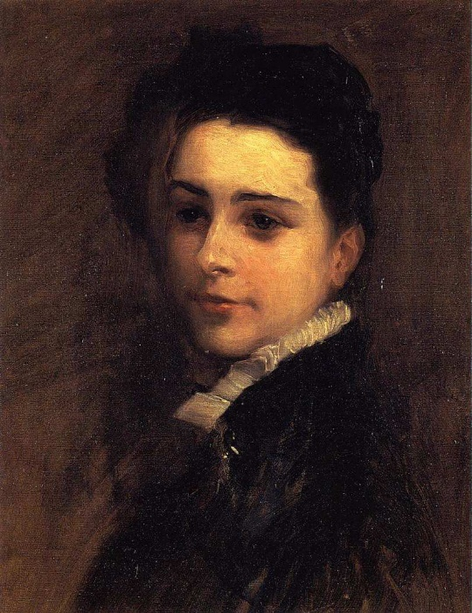
Annie Case (Mrs. Charles Deering)
John Singer Sargent 1877 (Posthumously)
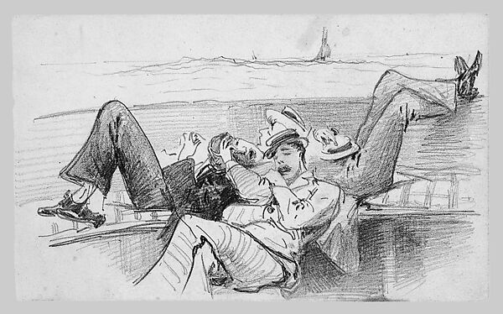
Siesta on a Boat (Gus, Daniel & Charles Deering)
John Singer Sargent Summer 1876

